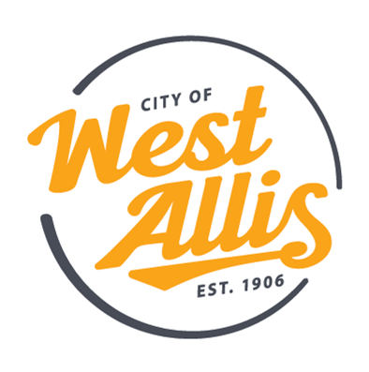

There’s no such thing as “routine” in this role. If you have concrete finishing or general construction experience and want a role where every day brings something new, we’d love to hear from you. As a Maintenance Repairer with our Department of Public Works, you’ll take on diverse, hands-on projects that keep our City’s infrastructure strong and our community safe.

Why You’ll Love This Role
- Work outdoors, operate equipment, and see the real impact of your work across the City.
- Enjoy steady, year-round employment with meaningful, community-focused projects.
- Join a collaborative, supportive team that values hard work, problem-solving, and craftsmanship.
- Be part of emergency response operations where your skills directly contribute to public safety.
- Expand your abilities with opportunities to learn new tools, equipment, and construction techniques.

What You’ll Do
- Perform routine maintenance on sanitary sewer mains using jetting equipment and inspection tools.
- Conduct hydro-excavation on catch basins and manholes using a vacuum excavator.
- Operate trucks, construction vehicles, and other equipment used in repair and maintenance work.
- Assist with building and repairing storm sewers, catch basins, and manholes, including job-site shoring.
- Perform asphalt maintenance tasks such as pothole repair, crack filling, and patchwork on streets, alleys, and sidewalks.
- Complete concrete finishing duties, including excavation, grading, forming, pouring, and finishing pavements, curbs, and sidewalks.
- Respond to emergency situations—snow removal, flooding, windstorms, natural disasters, and sewer pumping operations.
- Demonstrate strong teamwork, communication, and professionalism during routine and emergency work.

What You Bring
- High school diploma or equivalent.
- At least two years of recent paid concrete finishing experience.
- A strong work ethic, integrity, initiative, and accountability.
- Willingness to work nights, weekends, holidays, overtime, and extended hours during emergencies.
- Valid Wisconsin driver’s license and driving record that meets City standards.
- Ability to obtain a Wisconsin CDL (Class B, C with air brakes) and Tanker endorsement within 12 months of hire.
- Mechanical aptitude and sound judgment in fast-paced environments.
- Ability to use computers and mobile devices (iPad) and learn new software quickly.
- Experience working with the public is a plus.

Why Work for Us
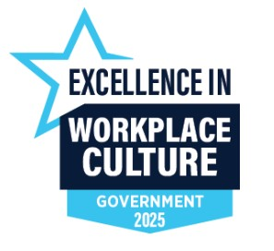

As you take care of our city, we’ll take care of you! We offer valuable benefits and perks, including:
- Health & Wellness:
  - City covers 88% of the medical premium (HRA plan).
  - FREE dental insurance.
  - FREE life insurance.
  - FREE long-term disability coverage.
- Retirement:
  - Participate in Wisconsin’s Retirement Fund with 7% city contribution.
- Generous Time Off:
  - Up to 25 days annually to start.
  - Holiday pay (up to 9 days).
- Professional Growth:
  - Paid training – we invest in our employees!
  - Tuition reimbursement.
  - Educational bonuses for certifications/training completed on city time.
  - Opportunities for advancement.
- Financial Perks:
  - Student loan repayment program.
  - Federal loan forgiveness.
  - Annual salary increases.
- Culture & Extras:
  - Paid employee recognition programs.
  - Employee wellness program.
  - Employee assistance program.
  - Pet insurance.
  - Employee events and more!
Click here to review the full job description.

